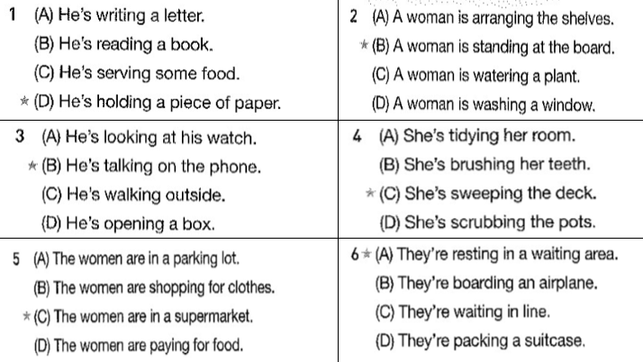

1a. he’s writing a letter

1b. he’s reading a book

1c. he’s serving some food

1d. he’s holding a piece of paper

2a. A woman is arranging the shelves (nối âm tô vàng)

2b. A woman is standing at the board

2c. A woman is watering a plant

2d. A woman is washing a window

3a. He’s looking at his watch

3b. He’s talking on the phone

3c. He’s walking outside

3d. He’s opening a box